Autism Friendly Puke Ariki

Social stories suited
for school visits
(Museum)

What is Puke Ariki?
Puke Ariki is a library, museum and information centre.
The library at Puke Ariki includes ‘Discover It’ (the children’s library), research centre and the general library.
The Museum contains different spaces filled with a lots of items including fossils, rocks, stuffed animals, art and Māori treasures.

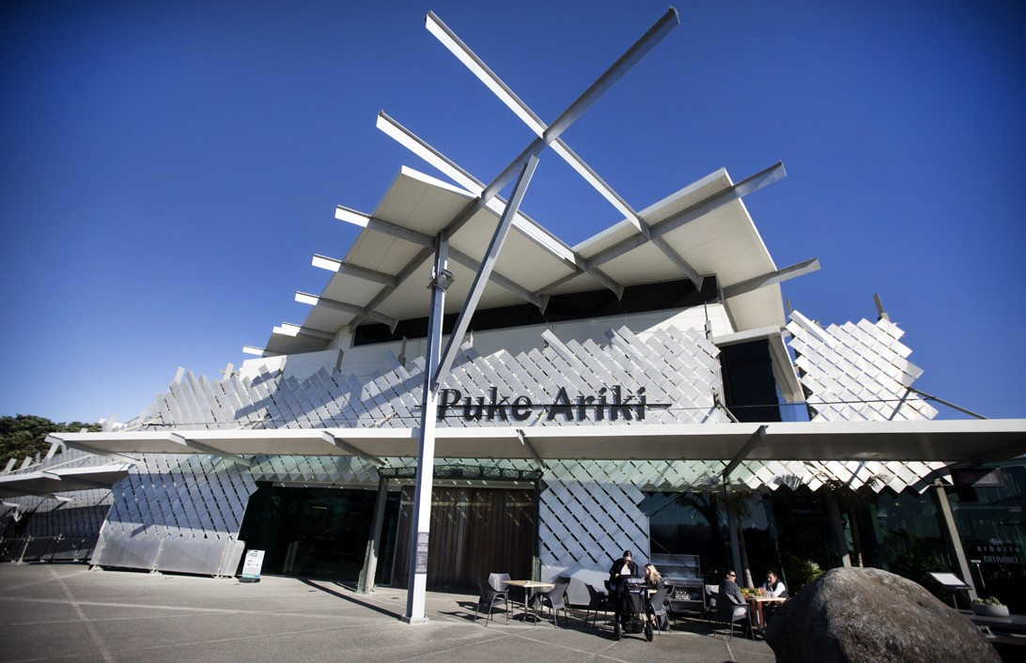

Inside the Museum
When I walk inside I will see a giant model shark (Megalodon) and a bird-like flying reptile hanging from the roof. They are both held up by a strong cable and will not fall on me.

I will listen to my teacher who will tell me and my class mates to sit down in one space.

If I have a school bag then I can put my bag in the bag trolley when my teacher tells me too.

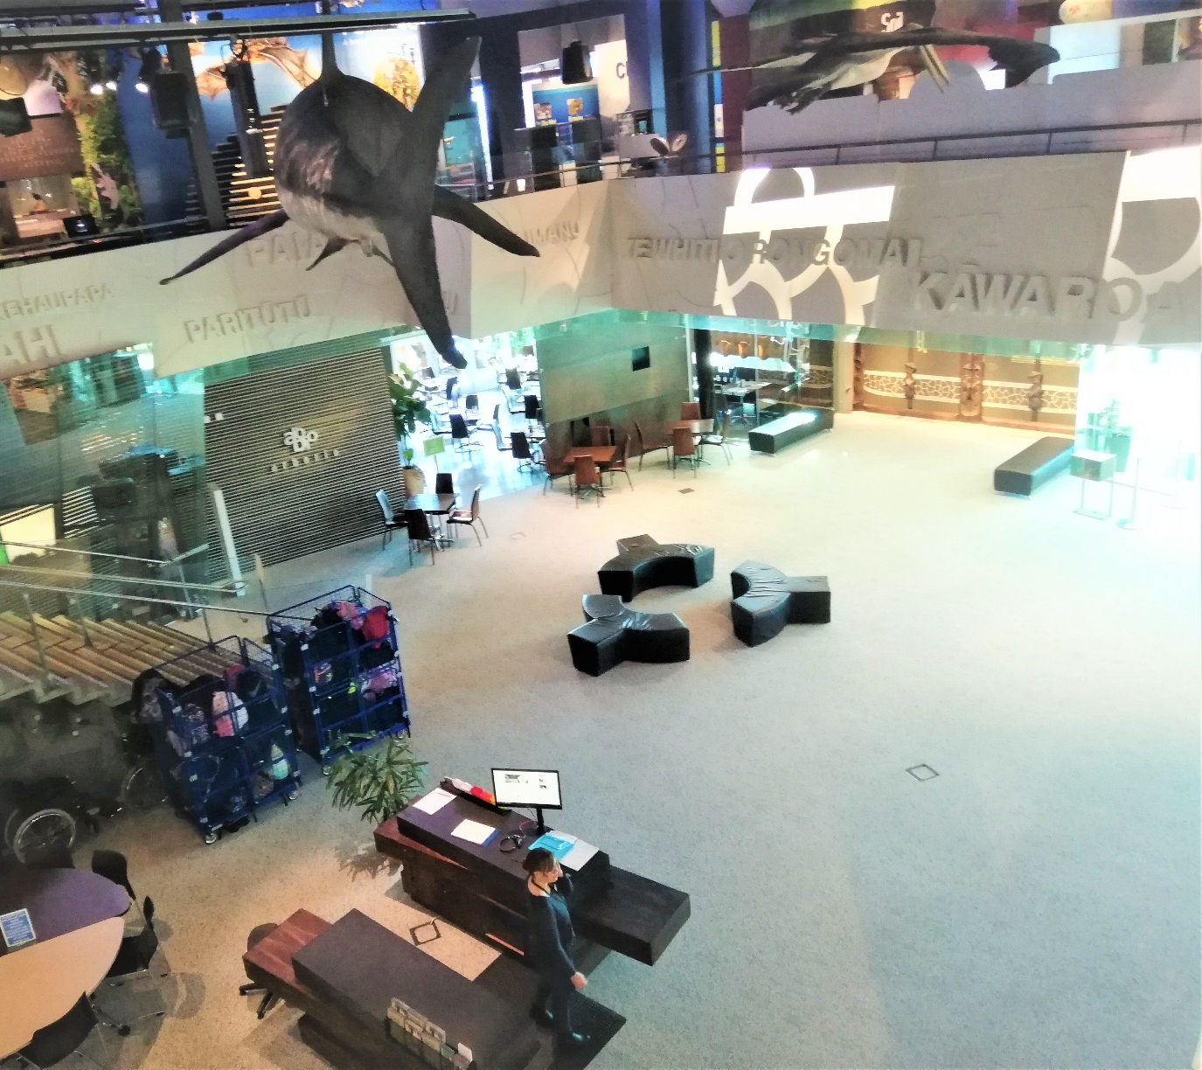

Museum Staff
Lots of helpful people work at Puke Ariki.
Puke Ariki staff all wear a Puke Ariki name badge.
If I get lost I can ask a person with this logo for help.

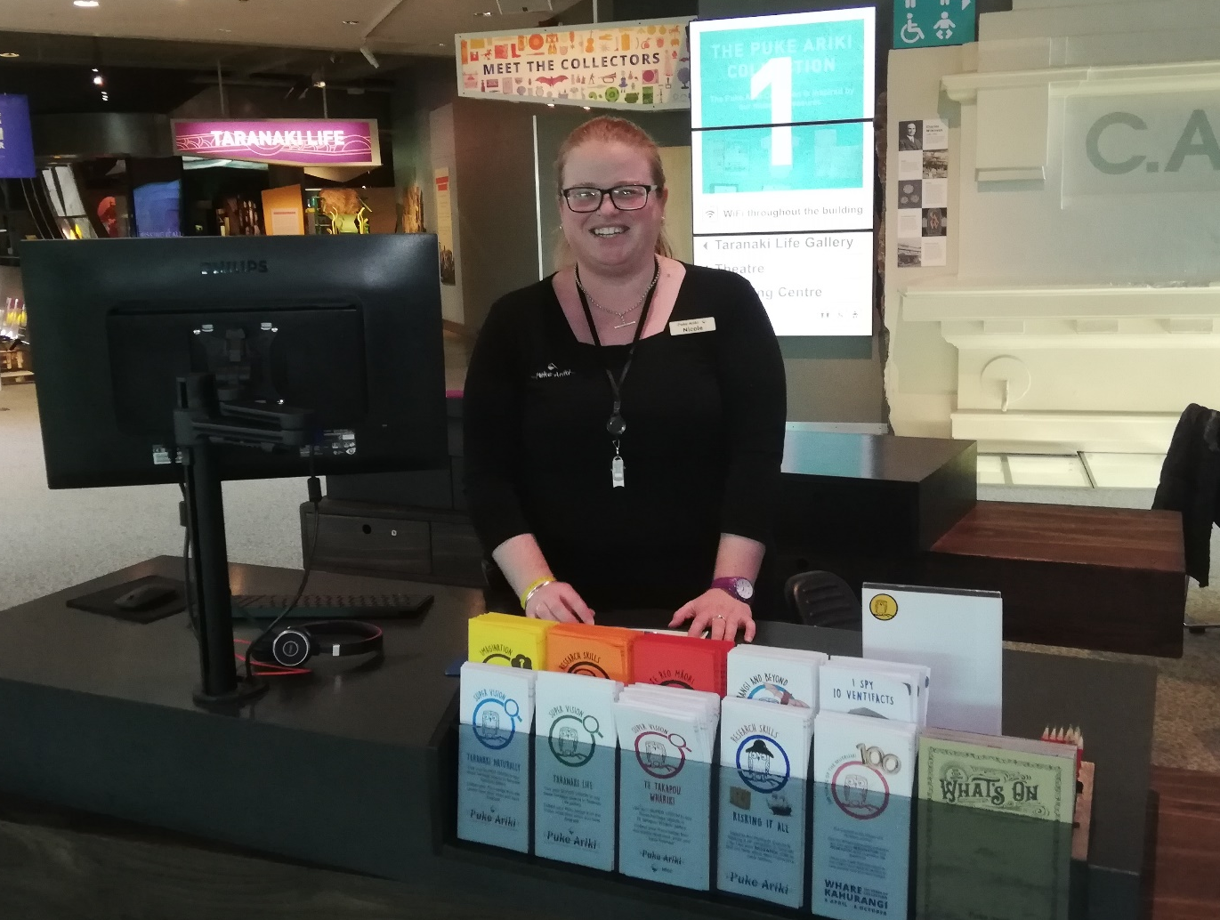

Toilets at the Museum
I will tell my teacher or another adult if I need to go to the toilet and they will take me to a bathroom. There are lots of bathrooms in the museum.
There may be other people in the bathroom as well.
I will remember to flush the toilet and wash my hands.

Food and Water
I can only eat food and drink water in the museum entrance.
I am not allowed to eat or drink anywhere else in the Museum.

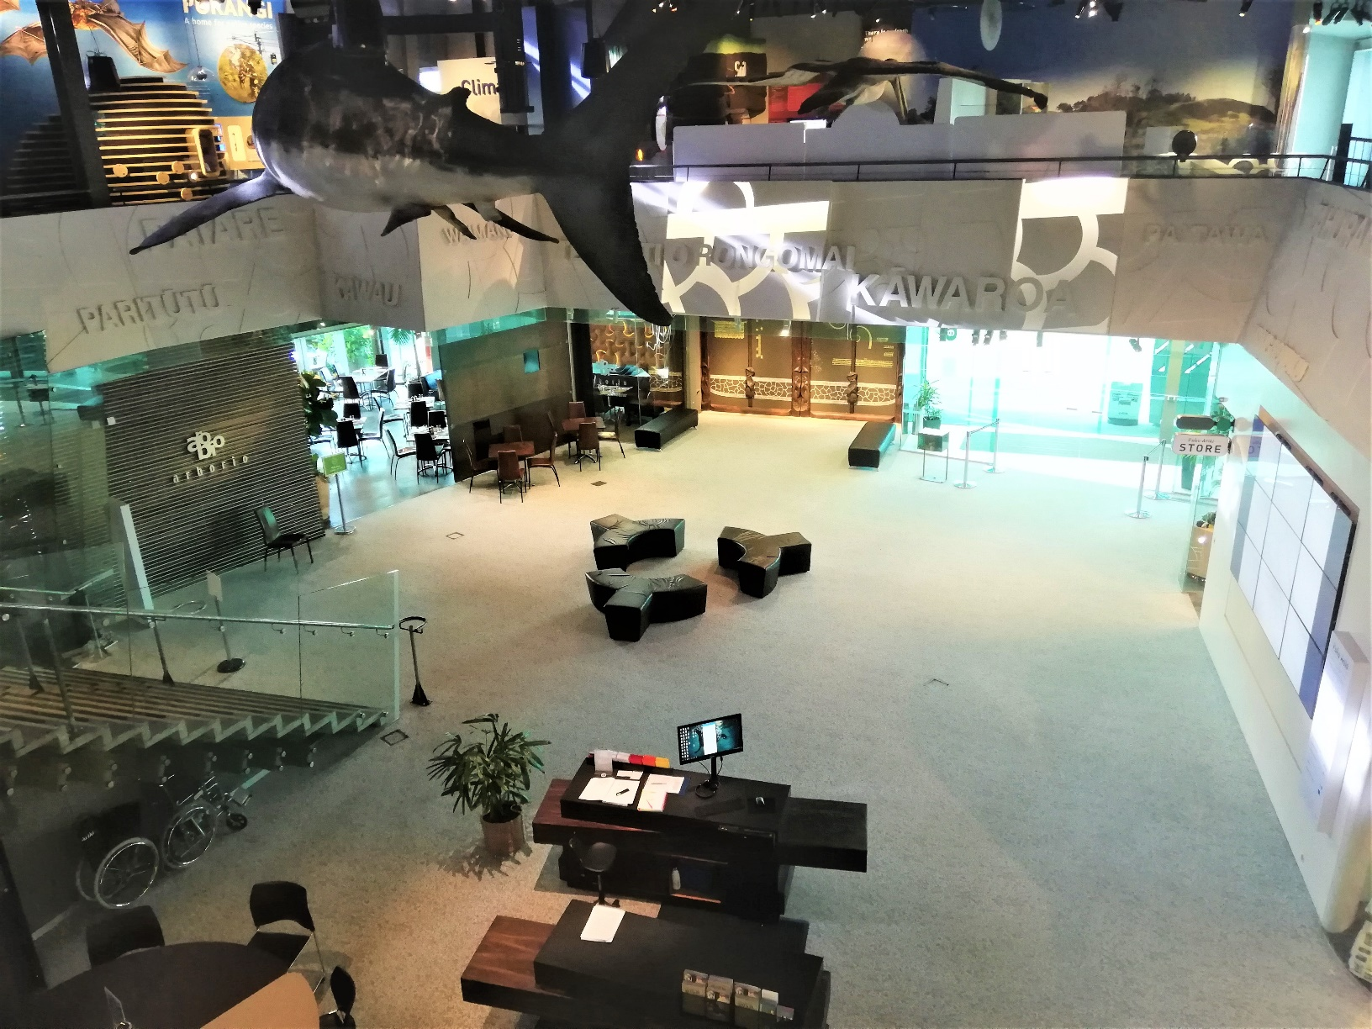

Booked Education Class
My class might have a special lesson with a museum teacher.
My teacher will introduce them to me and my classmates.
The museum teacher will welcome us to Puke Ariki and ask questions.
I will listen to the museum teacher and at the same time try and keep as still as I can.
If I want to answer a question I will put my hand up first. I will not interrupt when the teacher is speaking.
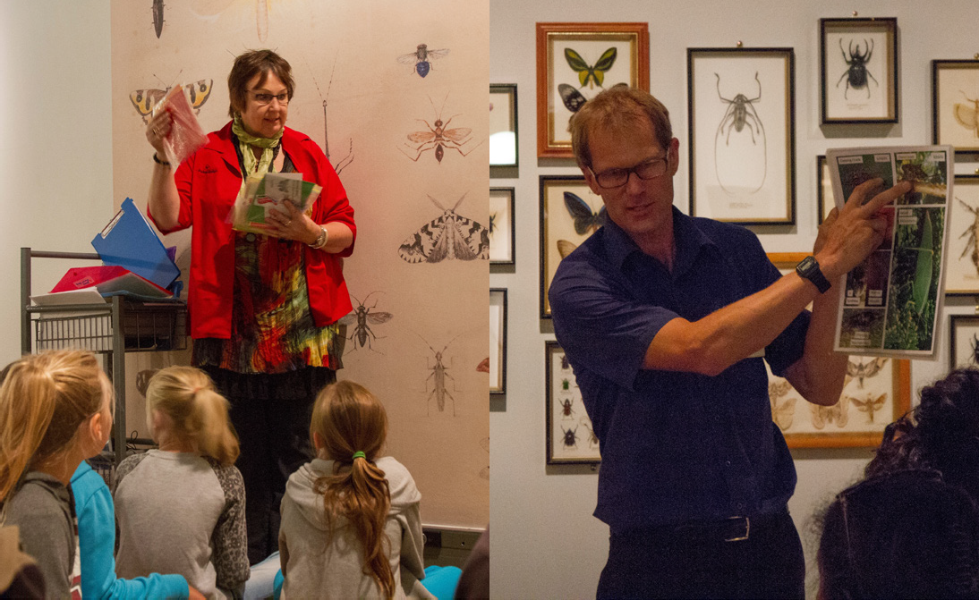

Museum Spaces
The museum has different rooms filled with a variety of items.
I will listen and wait for the teacher to tell me when and where I can go exploring in the Museum and they will also tell me what I can touch.
Some rooms might be dark or bright. If I don’t like being in a room and feel uncomfortable I will
tell an adult.

